Furling Headsail Measurement Form

(Please print and take to your boat for accurate measurements in millimetres only)
You can use this online form to enter your measurements and submit them to L.R Sails. To submit, click on the send button on the bottom of the page.

Customer Name:

Boat Model:
Email Address:(required)
Phone Number:

Sailing Type: Inshore Offshore Racing

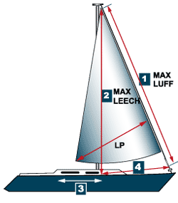
- Maximum Luff Length:
Attach the tape measure to the bottom shackle of the furling unit's top swivel and attach the headsail halyard to it's normal attachment on the top shackle of the swivel. Hoist the halyard to it's maximum hoist and measure down to the tack shackle on top of the furler drum.
mm

- (2)Maximum Leech Length:
Leave the tape hoisted in the position used for measurement #1 and measure to the front edge of the Headsail track - You will wrap the tape around the outside of the shroud to take this measurement
mm

3) Track Length:
Measure the length of the Headsail track.
mm

4) Track to Shackle:
Measure from tack at furler drum shackle to front edge of Headsail track.
mm

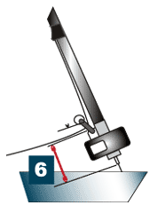
5) Furler Type:
Furler brand or Luff rope Size.
Brand of furler Luff rope Size: mm

6) Drum Height:
Measure the distance from the tack shackle on the top of the furling unit to forestay pin attachment at the bow.
mm

7) UV Cover :
Color and side (port or starboard side of sail)

Color Below
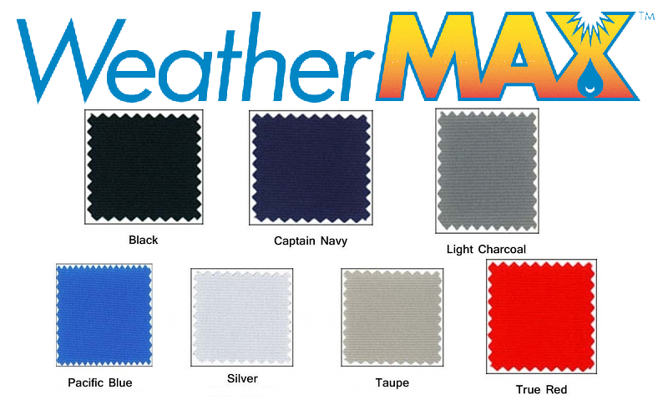

8) Desired Clew Location:
Select one. Low for high performance sails. Medium (lifeline height). High (boom height).
Low Medium High

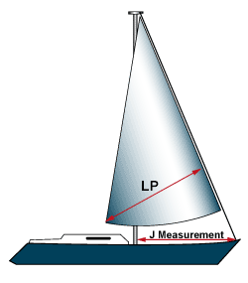
9) Luff Perpendicular (LP):
Enter the LP for your headsail from clew point to 90 degrees of luff.
LP:mm

10) J Measurement:
J is the base of the fore triangle measured along the deck from the headstay pin to the front of the mast.
mm

Comments

